Blue Christmas
A Service of Light in the Darkness
December 20, 2021 at 7:00 PM

PRELUDE

WELCOME
- Stars…………..introduction
- Write name of Loved One on Bag…..

CALL TO WORSHIP Drema Herron
ONE: In the beginning was the Word, and the Word was with God, and the Word was God. All things were made by God, and without God nothing came to be. What came to be through God was life, and this life was the light of the world.
ALL: The Light shines in the darkness, and the darkness has not overcome it.

HYMN O Come, O Come Emmanuel #119, v.1

OPENING PRAYER MaryEllen Hamlin
Holy and Gracious God, we come to you tonight to acknowledge the grief we are having at this Christmas time. Sometimes we even feel guilty because we have these feelings. The world tells us it is supposed to be a time of joy and celebration and yet it can be some of the darkest times for us. We offer up to you all those things we are feeling and all the situations that worry us and ask that you heal our pains and remove our loneliness. Help us to recognize the pressures of the season that drag us into the darkness and turn them over to you. Help us to feel your love and hear your assurance that you travel beside us, and help carry our burdens. In Jesus' name we pray, Amen.

SONG OF COMFORT Within Our Darkest Night Taizé
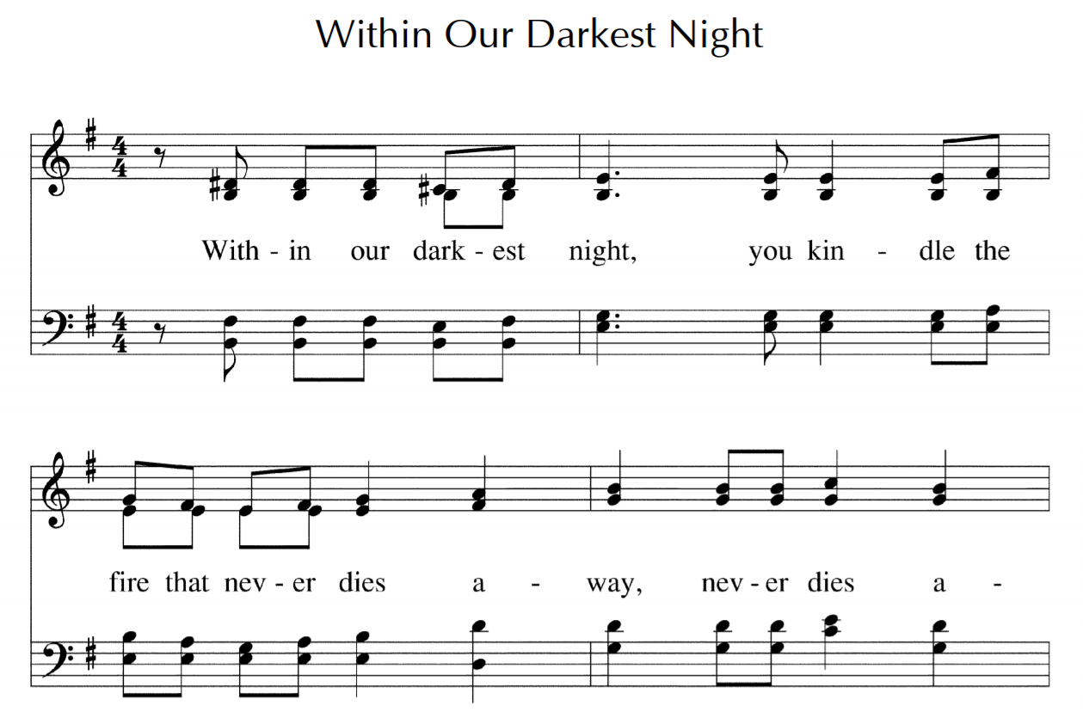
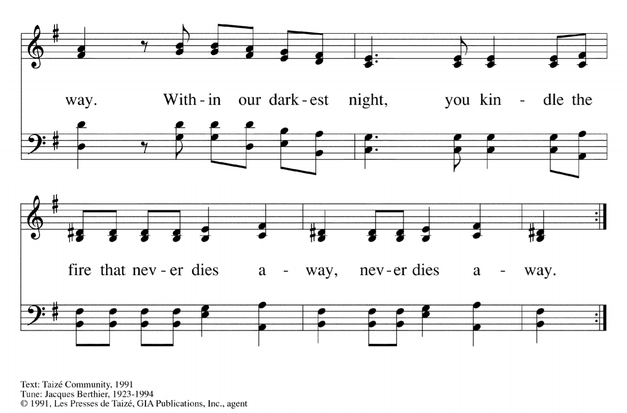

A READING FROM THE PSALMS Beth Schabel
Have pity on me, Lord, for I am weak; heal me, Lord, for my bones are racked.
My spirit shakes with terror; how long, O Lord, how long?
I grow weary because of my groaning;
every night I drench my bed with tears.
My eyes are wasted with grief.
I sought the Lord, and he answered me and delivered me out of all my terror.
Look upon him and be radiant, and let not your faces be ashamed.
I called in my affliction and the Lord heard me
and saved me from all my troubles.
The angel of the Lord encompasses those who fear him,
and he will deliver them.
Taste and see that the Lord is good; happy are they who trust in him!
The eyes of the Lord are upon the righteous, and his ears are open to their cry.
The righteous cry, and the Lord hears them
and delivers them from all their troubles.
The Lord is near to the brokenhearted
and will save those whose spirits are crushed.
Many are the troubles of the righteous, but the Lord will deliver us from them all.
The Lord will deliver us!

SONG OF COMFORT Within Our Darkest Night Taizé
LITANY OF REMEMBRANCE AND LIGHT Linda Idoine

SPECIAL MUSIC “River” Beth Schabel

LITANY OF REMEMBRANCE AND LIGHT

THE LORD’S PRAYER

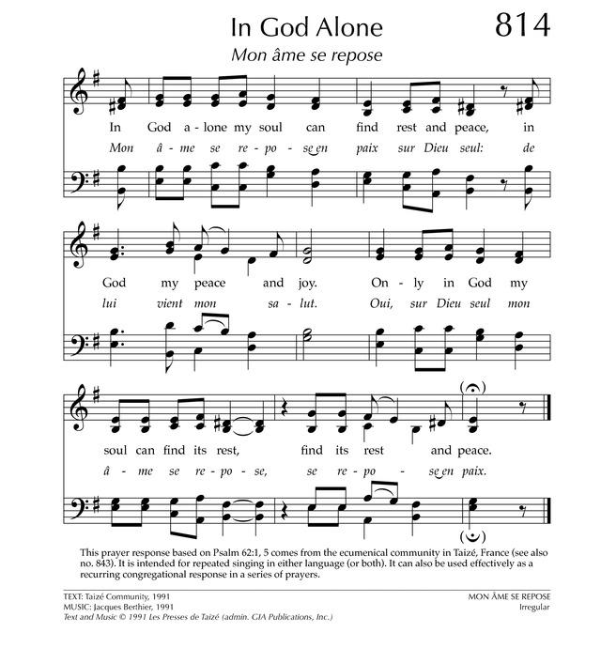
*HYMN OF PEACE In God Alone Taizé

*REMEMBERING OUR BELOVEDS WITH LIGHT AND STARS
You may come forward to the communion table and light a candle
representing all those whose lives touched yours and whose memory you cherish.

SPECIAL MUSIC Jan Green

SCRIPTURE READING Isaiah 40:27-31 Ruth Anne Ruehr
Why do you say, O Jacob,
and speak, O Israel,
“My way is hidden from the Lord,
and my right is disregarded by my God”?
Have you not known? Have you not heard?
The Lord is the everlasting God,
the Creator of the ends of the earth.
He does not faint or grow weary;
his understanding is unsearchable.
He gives power to the faint,
and strengthens the powerless.
Even youths will faint and be weary,
and the young will fall exhausted;
but those who wait for the Lord shall renew their strength,
they shall mount up with wings like eagles,
they shall run and not be weary,
they shall walk and not faint.

*HYMN Silent Night

*BENEDICTION
Thank you so much for joining us for this Longest Night Service. The nights are long now, but we trust that little by little the light will return. God bless you and your family this Christmas and while there is sorrow, we pray you might find spaces for light and joy.

As we close I want to read to you this poem by Jan Richardson called “What the Light Shines through: A Healing Blessing”

Where pain does not touch you. Where hurt does not make its home.
Where despair does not haunt you. Where sorrow does not dwell.
Where disease does not possess you. Where death does not abide.
Where horror does not hold you. Where fear does not raise its head.
Where your wounds become doorways. Where your scars become sacred maps.
Where tears become pools of gladness. Where delight attends your way.
Where every kindness you have offered returns to you.
Where each blessing you have given makes its way back to you.
Where every grace gathers around you.
Where the face of love mirrors your gaze.
Where you are what the light shines through

POSTLUDE
You are welcome to stay and pray – or just sit in the quiet candlelight – for as long as
you wish. We ask that you please maintain quiet in the sanctuary for the benefit of those who desire silence.

†

